University of Washington

iSchool Info 330

# Module 03 Assignment - Enhancing a Database

In this module's assignment, you will learn how work with a database using the SQL language.

## Assignment Videos

Please watch the following Videos:

|  |
| --- |
| Assignment Videos < 120 min (Links are to external sites) |
| [SQL 2012 Basic Queries Lab 1.1 - 18](https://youtu.be/OsZ5Tqn1W0Y?list=PLM-CGnaD3kr0jl13yR3DexukWlUFd0s7Z) |
| [SQL Aggregation queries using Group By, Sum, Count and Having - 10](https://youtu.be/IVMfDpCGwK4) |
| [SQL 2012 Joining Tables lab 1.2 - 13](https://youtu.be/3lSQI79XLUw?list=PLM-CGnaD3kr0jl13yR3DexukWlUFd0s7Z) |
| [TSQL: How To Count NULL (And/Or Blank) Values - 4](https://youtu.be/xIFz7qAGGfw) |
| [SQL Server Programming Part 14 - Transactions - 23](https://youtu.be/is03uRYFgqc) |
| [Functions-01 Using Built In Functions - 33](https://youtu.be/ShQ6Wm1pNks?list=PLfycUyp06LG_ShpiOSTkQmu69sZD2Ng13) |

## Assignment Examples

Read and try out some SQL statements on the W3Schools website. This website has short articles about many subjects and we will use this site throughout the course. In many of these articles you will find a "Try it Yourself" section where you can experiment with the SQL language interactively. You only need to scan though these pages so don't spend a lot of time on each.

This website will become one of your most used "Go To" sites as you progress in your learning. So please check out the following pages this week!

|  |
| --- |
| Examples < 60 min (Links are to external sites) |
| [SQL Syntax](https://www.w3schools.com/sql/sql_syntax.asp) |
| [SQL Select](https://www.w3schools.com/sql/sql_select.asp) |
| [SQL Select Distinct](https://www.w3schools.com/sql/sql_distinct.asp) |
| [SQL Where](https://www.w3schools.com/sql/sql_where.asp) |
| [SQL And, Or, Not](https://www.w3schools.com/sql/sql_and_or.asp) |
| [SQL Order By](https://www.w3schools.com/sql/sql_orderby.asp) |
| [SQL Select Top](https://www.w3schools.com/sql/sql_top.asp) |
| SQL Min and Max |
| SQL Count, Avg, Sum |
| SQL Like |
| SQL Wildcards |
| SQL In |
| SQL Between |
| SQL Aliases |
| SQL Group By |

## Assignment Reading

Since the course does not have an official text you will use various websites for your studies. This is a great way to learn new subjects and practicing it will be something you will use for years to come! Please read the following web pages:

|  |
| --- |
| Reading < 120 min (Links are to external sites) |
| <https://technet.microsoft.com/en-us/library/bb264565(v=sql.90).aspx> |

## Assignment Document

Write a one-page document that articulates the answer to the following questions. Use at least one well-formed paragraph per question. Using only a sentence or two is fine, but it must make sense and be well formed. (Please use MS Word or a compatible word processor)

1. Explain what are the four basic SQL statement used to create, read, update and delete data.
2. Explain when do people directly or in-directly use SQL statements.
3. What type of jobs use SQL statements directly and where did you find this information.

***Important:*** *Your document must look professional to get full points! Use my example template and video, in the General Files and Topics module, as a guide for what I expect a professional paper to look like. Make sure you format it like a college paper instead of the text message. Things like your name, date, class, citations, introductory and summary paragraphs are always expected! Not putting these in the document you will cost you!*

## Assignment Task

I would like you to practice what you have learned in this module. To do so, you will write a SQL Script answers several requests for data found in the Northwind database.

You use the provide starter file, Assignment03.sql, to get you started.

-- Data Request: 0301

-- Date: 1/1/2020

-- From: Jane Encharge CEO

-- Request: I want a list of customer companies and their contact people

-- Needed By: ASAP

**Hint**: The results will look like this…

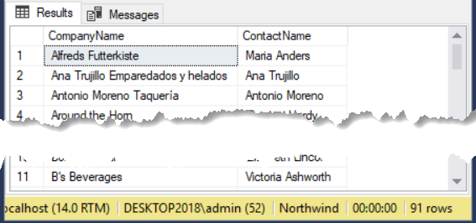

-- Data Request: 0302

-- Date: 1/2/2020

-- From: Jane Encharge CEO

-- Request: I want a list of customer companies and their contact people, but only the ones in US and Canada

-- Needed By: ASAP

**Hint**: The results will look like this…

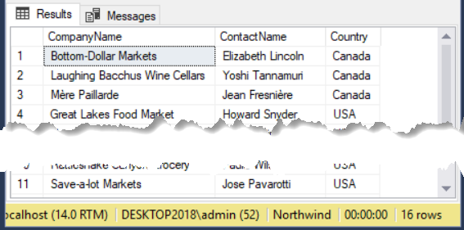

-- Data Request: 0303

-- Date: 1/2/2020

-- From: Jane Encharge CEO

-- Request: I want a list of products, their standard price and their categories. Order the results by Category Name

-- and then Product Name, in alphabetical order

-- Needed By: ASAP

**Hint**: The results will look like this…

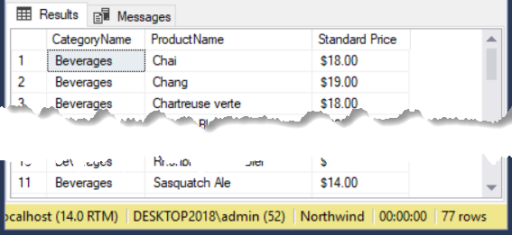

-- Data Request: 0304

-- Date: 1/3/2020

-- From: Jane Encharge CEO

-- Request: I want a list of how many customers we have in the US

-- Needed By: ASAP

**Hint**: The results will look like this…

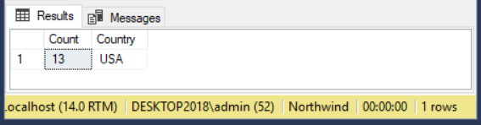

-- Data Request: 0305

-- Date: 1/4/2020

-- From: Jane Encharge CEO

-- Request: I want a list of how many customers we have in the US and Canada, with subtotals for each

-- Needed By: ASAP

**Hint**: The results will look like this…

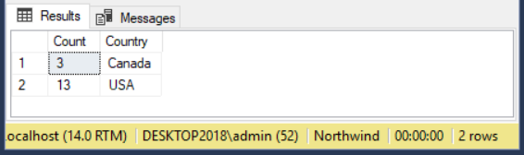

# Grading

Student work will be evaluated on a point system using the following general guidelines found on the Course Syllabus page. Make sure you read and understand this.

**NOTE:**  It is very possible to get a 3.9 or better from this course, but you have to earn it! Do not expect to get 100% of the possible points without extra effort on your part. If you want to excel in this course, you must submit **excellent**work!

# Submit your work

After you have completed your Word document and SQL Script, place both into a folder called Assignment03**FirstInitialLastName** and Zip the folder. Upload the Zipped folder to the Canvas web site.

